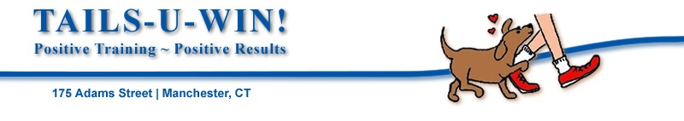
(860) 646-5033 | www.tailsuwin.com

Member Waiver – June 2019 thru June 2020
Membership can be purchased at http://tailsuwin.com/pages/membership.htm
I (name),_________________________________________________

Of Address: _______________________________________

_______________________________________

Phone (including area code) Home ______________________________

Cell ______________________________

Email Address: _________________________________________________

Agree to abide by the rules and regulations of Tails-U-Win! I also agree not to hold Tails-U-Win! liable for any accidents and/or injuries that may occur to either myself or my animals while on the property of Tails-U-Win! for the purpose of ring rental, training of my dogs by myself and/or my dogs by any owner, agent or subcontractor of Tails-U-Win! or by anyone not an owner agent or subcontractor of Tails-U- Win!

Signature_____________________________________________ Date____________

Please list the breed(s) you work with________________________________________

Please check your areas of interest:
Competition Obedience  Breed Handling  Agility  Nose Work/Scent Fun | ____  ____  ____  ____ | Weight Pulling  Flyball  Cross Training  Other | ____  ____  ____  ____

For office use only

Amount Paid: $_________  Date Received: _________ | Check #: ____________  Cash: _____________  Credit Card: ___________ | Membership Expires: ______  DBP?: ___________________  Confirmation Email Sent: ___
For office use only:
Receipt | DBP: Discount Applied, Added to Member Newsletter – Confirmation Email Sent – Waiver Marked | File

